
Construction of New Supramolecular Structures via Arene-perfluoroarene Interactions: Controlled Self-assembly of Paddle-wheel Complexes
Takahiro Itoh, Mio Kondo, Mari Kanaike and Shigeyuki Masaoka
Institute for Molecular Science, Myodaiji, Okazaki 444-8787, Japan
e-mail address: titoh@ims.ac.jp

Control over the self-assembling process of metal complexes is of key importance to construct supramolecular materials and nano devices, which have unique physical and chemical properties. Paddle-wheel complexes consisting of two metal ions and four monoanionic bidentate ligands attract much attention because of their highly symmetric (D_{4h}) structure suitable for the construction of continuous structure. In this study, we aimed to construct supramolecular architectures using paddlewheel dimer units via multipoint arene-perfluoroarene interactions.
To construct continuous structures of paddle-wheel units, we designed and synthesized a novel ligand, C₆F₅C₂C₆H₄CO₂H (HL). HL contains both benzene and perfluorobenzene moieties and can show arene-perfluoroarene interactions. Using this ligand, the syntheses of a paddle-wheel dimer was performed. Two kinds of complexes, Rh₂(O₂CCF₃)₂(L)₂(3-pentanone)₂ (1) and Cu₂(L)₄(THF)₂ (2) were obtained. As shown in Figure 1, the molecular arrangements of 1 and 2 are stabilized by complementary interactions in the crystalline state. Interestingly, in the crystal packing of 2, porous structure was formed by stacking of the two dimensional sheets via interaction between ligands. The pore entrance size of 2 was estimated to be 13.8 x 5.8 Å² and THF molecules are contained as guest.
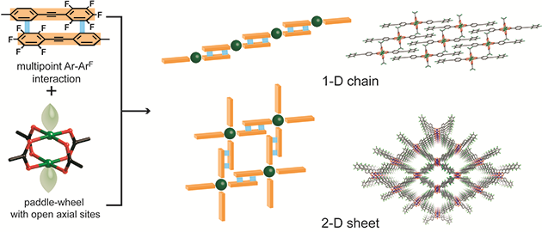
Figure 1 Controlled self-assembly of paddle-wheel complexes via arene-perfluoroarene interactions

[1]. T. Itoh, M. Kondo, M. Kanaike, and S. Masaoka, CrystEngComm, 2013, 15, 6122-6126.

