Taro SOKEN

Grade: Master course student, 2nd grade (M2)
Affiliation: The Graduate University for Advanced Studies [SOKENDAI]
Address: Higashiyama 5-1, Myodaiji, Okazaki, Aichi 444-8787 Japan
Phone: +81-564-59-XXXX Fax: +81-564-59-XXXX
E-mail: souken@ims.ac.jp

Date of Birth 19XX .Nov.14.

Sex Male

Education
20XX – 20XX B. S. Nagoya University
20XX – present The Graduate University for Advanced Studies [SOKENDAI]

Publications
- "Arene-perfluoroarene Interactions for Crystal Engineering of Metal Complexes: Controlled Self-assembly of Paddle-wheel Dimers", T. Soken, M. Fuji, M. Koi, and S. Okazaki, CrystEngComm, 20XX, in press.
- "Dispersed Ru Nanoclusters Transformed from a Grafted Trinuclear Ru Complex on SiO₂ for Selective Alcohol Oxidation"
S. Murai, M. H. Lim, T. soken, W. Thumrongpatanaraks, M. Fuji, S. Okazaki, T. S. A. Hor, and M. Toki, Dalton Trans., 20XX, in press.

Presentations and Awards
- Taro Soken, Masaya Okamo, Gen Nakai, Mei Fuji, Satoshi Okazaki, “Syntheses, Structures and Redox Reactions of Rh(II) Paddlewheel Dimer Complexes with Complementary Interactions”, Nagoya Symposium 20XX, Nagoya, Japan, May, 20XX
- Taro Soken, Masaya Okamo, Gen Nakai, Mei Fuji, Satoshi Okazaki, “Complementary Interactions in Crystal Engineering : Syntheses, Structures and Redox Reactions of Rh(II) Paddlewheel Dimer Complexes, 20XX Asian Core Winter School, Busan, Korea, January, 20XX

Research Interests
- Multielectron Transfer Reaction Catalyzed by Transition Metal Complexes
- Coordination Chemistry toward Artificial Photosynthesis
- Thermal and Photochemical Activations of Small Molecules by Transition Metal Complexes
Construction of New Supramolecular Structures via Arene-perfluoroarene Interactions: Controlled Self-assembly of Paddle-wheel Complexes
Control over the self-assembling process of metal complexes is of key importance to construct supramolecular materials and nano devices, which have unique physical and chemical properties. Paddle-wheel complexes consisting of two metal ions and four monoanionic bidentate ligands attract much attention because of their highly symmetric (D_{4h}) structure suitable for the construction of continuous structure. In this study, we aimed to construct supramolecular architectures using paddlewheel dimer units via multipoint arene-perfluoroarene interactions.
To construct continuous structures of paddle-wheel units, we designed and synthesized a novel ligand, C₆F₅C₂C₆H₄CO₂H (HL). HL contains both benzene and perfluorobenzene moieties and can show arene-perfluoroarene interactions. Using this ligand, the syntheses of a paddle-wheel dimer was performed. Two kinds of complexes, Rh₂(O₂CCF₃)₂(L)₂(3-pentanone)₂ (1) and Cu₂(L)₄(THF)₂ (2) were obtained. As shown in Figure 1, the molecular arrangements of 1 and 2 are stabilized by complementary interactions in the crystalline state. Interestingly, in the crystal packing of 2, porous structure was formed by stacking of the two dimensional sheets via π−π interaction between ligands. The pore entrance size of 2 was estimated to be 13.8 x 5.8 Å² and THF molecules are contained as guest.
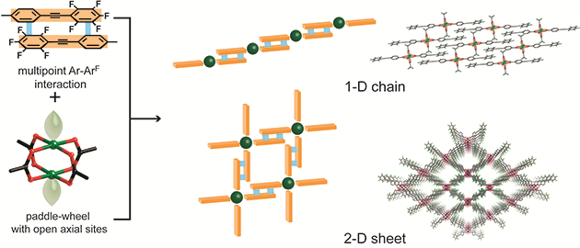
Figure 1 Controlled self-assembly of paddle-wheel complexes via arene-perfluoroarene interactions

References
- T. Soken , M. Bunshi , M. Fuji, and S. Okazaki , CrystEngComm, 20XX, in press.

